Friends and Family Comments May 2023
RESULTS: 101

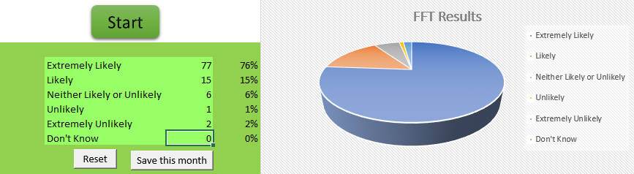
- Very helpful
- GP dealt with medical problem in a professional and kind way
- All went very well
- Receptionist was really busy but still had time to smile, doctor was very thorough and listened to and acted on my concerns
- Very thorough consultation. Very knowledgeable, great information given out
- I attended the surgery for a blood test and everything was done in a professional manner and on time i was in and out in no time at all what more could you ask for
- Very helpful
- I've been part of this practice since birth, and have never had any cause for complaint. I'm now 70 years old, so what does that tell you
- Got my results went in on time and Joanne was very helpful and friendly
- Very good staff
- I had no issues
- Print friendly service
- I just rang the surgery and got appointment straight away. The Doctor listened to my symptoms, then asked me questions and straight away prescribed medication. The Doctor was very professional with a caring attitude, Fantastic Surgery
- I am always happy with the service. However on this occasion it took 3 attempts to get an appointment. I am not happy about having to phone at 8:30am for a same day appointment. Due to my working days, I cannot always phone at 8:30am, which has resulted in a 3 day delay to see a doctor for a referral for an x-ray. I trust the surgery procedures will get back to some sort of normality very soon
- Dr Jeyam is an excellent Doctor and the practice staff are really helpful
- Because, doctor number 1
- Good
- The person who took my blood for testing, was very professional. She told me how long it was going to take what not to worry about and reassured me that I was in a safe place. She had extreme confidence in the work that she was doing, which evidently made me feel at ease
- Phoned early morning and was given an appointment to attend only 2 hours later
- Excellent service
- The doctor was very helpful
- Good
- Speedy appointment, receptionist listened to the problem.
- Good
- Yes his really good never felt any pain All the staff are always obliging
- Caring, empathetic, clear and professional
- Pleasant reception, clean waiting room
- Always keep good timing and extremely pleasant staff
- Went in on time and the nurse was very good
- Professional
- Excellent patient service and care as usual
- I was treated right by this Doctor and put my mind at ease
- Resolved all issue. Great knowledge. Exceptional level of care
- Fantastic service
- Drs very good. Nurse today seemed disorganised. She didn’t know where plasters were and said this herself
- Very good service
- On time. Sorted issue
- Good at there job ???? made sure I was okay
- Blood pressure test only quick easy on time doctors polite and informative many thanks
- The practice invariably offers a caring and professional service thank you
- Quick and pleased with the care and advice
- Brilliant reception Quick service
- Very good and efficient
- Quick and efficient
- Very good
- Very happy with our surgery thanks
- The doctor explained about high blood pressure. I was pleased
- Very friendly and helpful and professional
- Speed with which I was dealt with. In and out before my appointment time
- Went for a check-up for my short breaths I’ve been suffering, rang the doctors surgery got the appointment on the same day, found out I had a chest infection, doctor prescribed me 2 different Antibiotics with a blue inhaler
- Very good
- Best doctor, number 1
- Professional friendly and polite
- Prompt efficient service
- Clear information and pleasant connections with all staff involved, from the phone call, receptionist and doctor I saw
- Because Anita is always brilliant pity she is retiring

